**Assignment Tasks**

**Question 1.** Retrieve the total number of orders placed by each user. Display the user's name and the total number of orders they have placed. Sort the results in descending order based on the number of orders.

**Question 2.** Find the average price of menu items for each restaurant. Display the restaurant name and the average menu item price. Sort the results in ascending order based on the restaurant name.

**Question 3.** Identify the restaurant with the highest total sales (sum of order amounts). Display the restaurant name and the total sales amount.

**Question 4.** Find the number of orders placed in each city. Display the city name and the number of orders. Sort the results in descending order based on the number of orders.

**Solutions:**

1. SELECT B.name, COUNT(A.user_id) Total_no_Orders

FROM orders A LEFT JOIN user_info B

ON A.user_id = B.ID

GROUP BY A.user_id

ORDER BY COUNT(A.user_id) DESC;

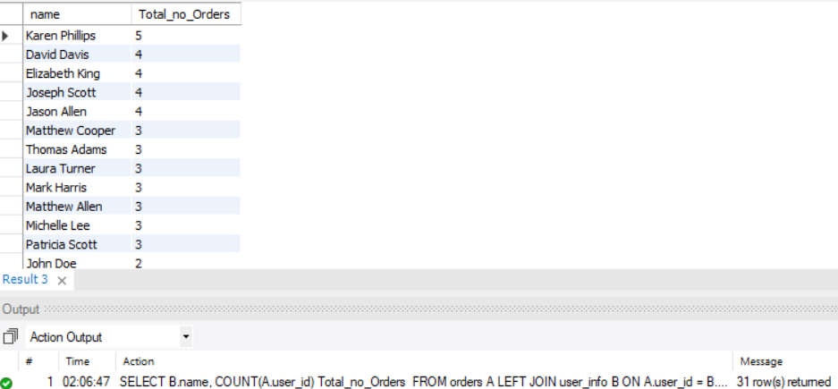

1. SELECT B.name, ROUND(AVG(A.price)) Average_item_price

FROM menuitems A LEFT JOIN restaurant_info B

ON A.restaurant_id = B.restaurant_id

GROUP BY A.restaurant_id

ORDER BY B.name;

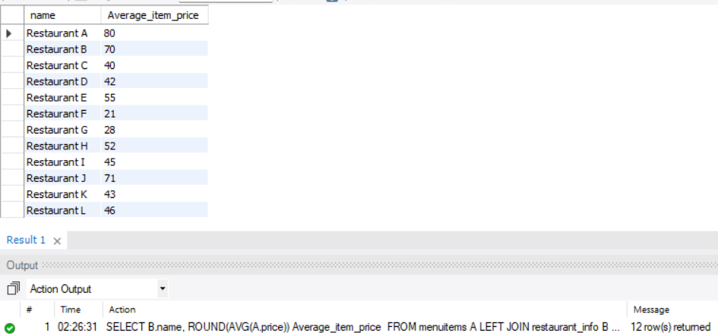

1. SELECT B.name, SUM(A.total_amount) Total_sales_Amount

FROM orders A LEFT JOIN restaurant_info B

ON A.restaurant_id = B.restaurant_id

GROUP BY A.restaurant_id

ORDER BY SUM(A.total_amount) DESC

LIMIT 1;

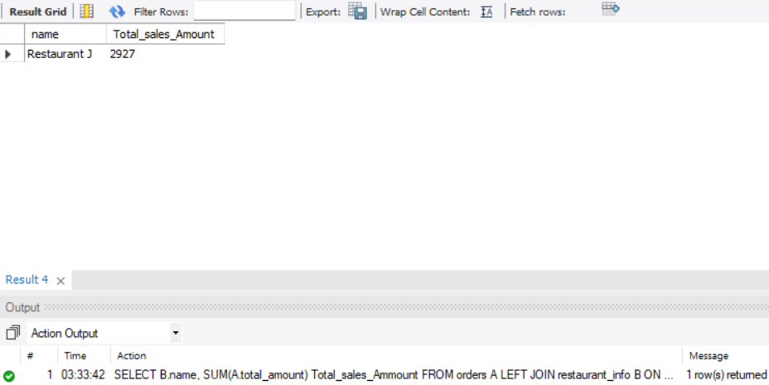

1. SELECT C.city_name, COUNT(A.order_id) No_Of_Orders

FROM orders A

LEFT JOIN restaurant_info B

ON A.restaurant_id = B.restaurant_id

LEFT JOIN city C

ON B.city_id = C.city_id

GROUP BY C.city_id

ORDER BY COUNT(A.order_id) DESC;

